1. **Monitor Your Estimated Charges Using CloudWatch**

**Step 1: Enable Billing Alerts**

**Step 2: Create a Billing Alarm**

**Step 3: Check the Alarm Status**

**Step 4: Create & Subscribe to SNS Topic**

**Step 5: Send a notification all the stakeholder, if AWS resource pricing reaches the threshold value.**

(Billing metric not available, Creating ec2 alarm instance)

Go to cloudwatch, Alarms

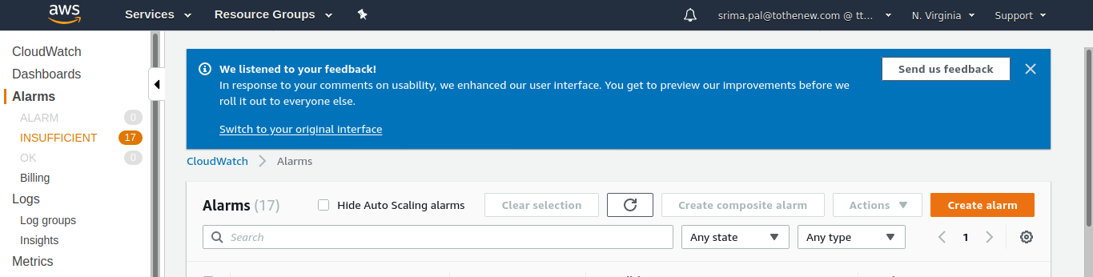

Select metric (EC2)

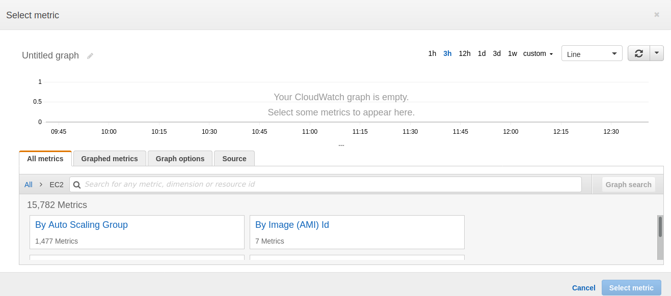

Per instance metric

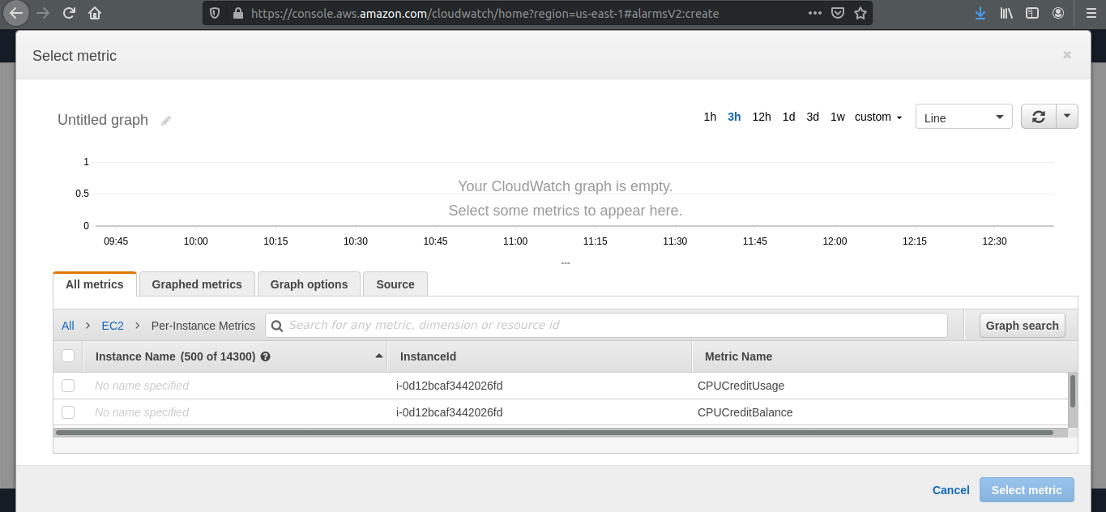

Copy the instance id and search for the instance, select CPU Utilization

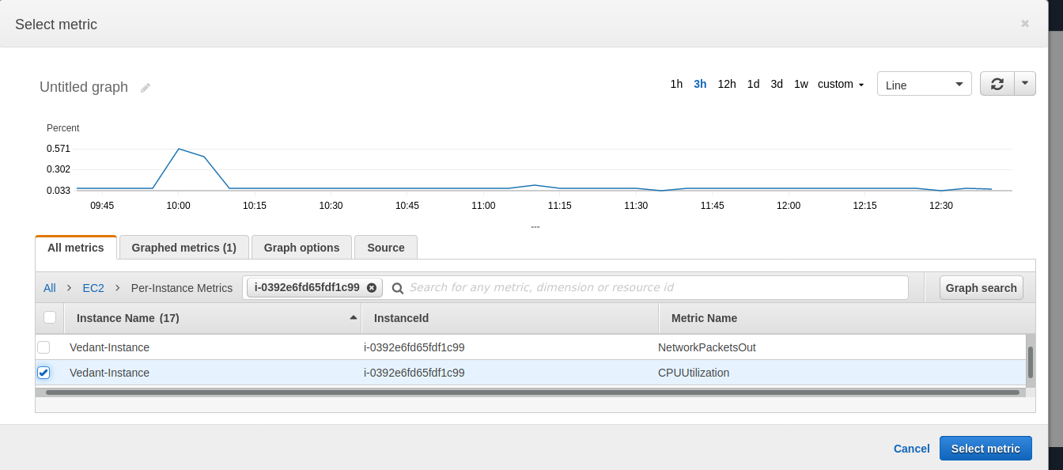

Click on select metric

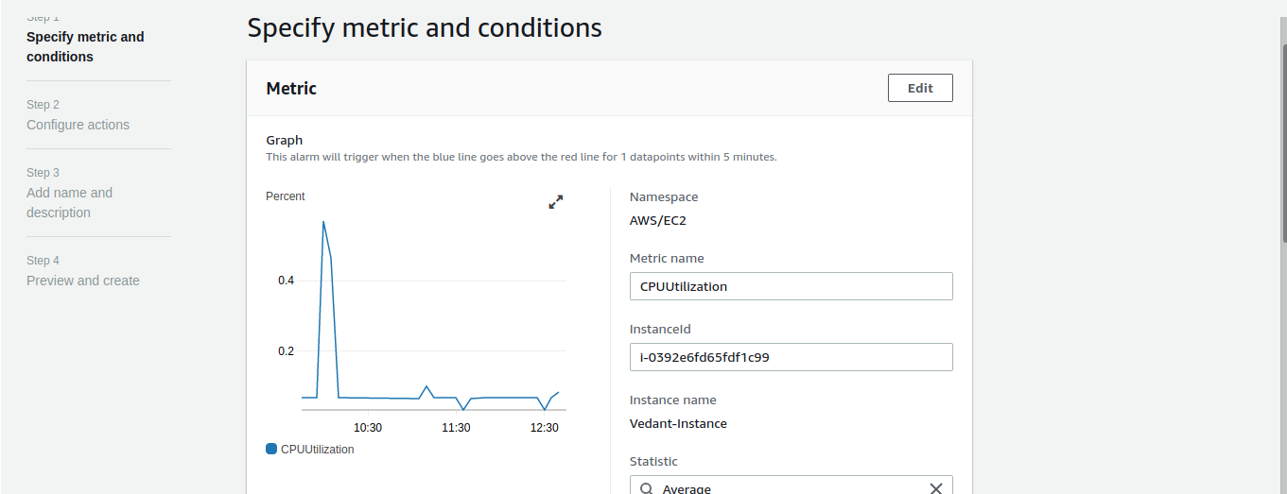

Give threshold, and click next

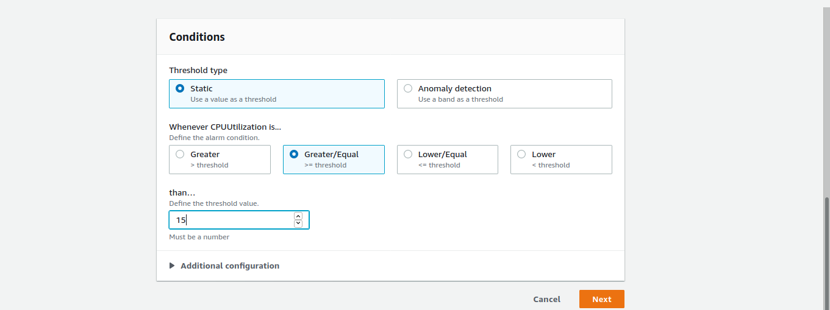

Now select the created(existing topic)

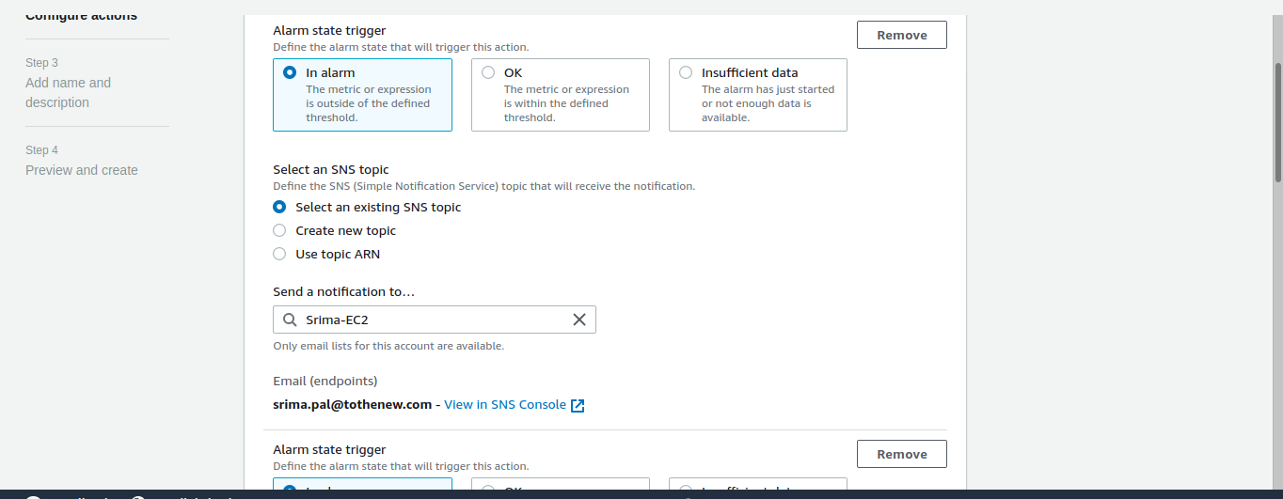

Create SNS topic to send notification

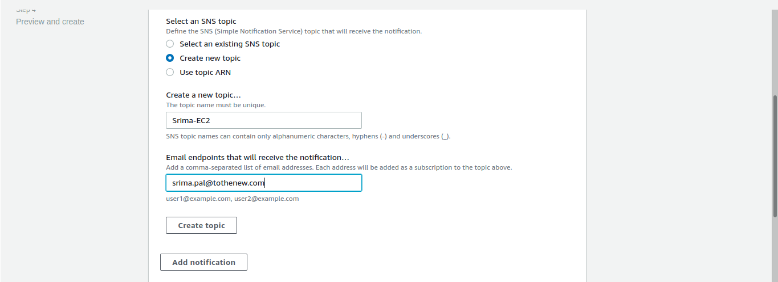

Create EC2 action on reaching the threshold

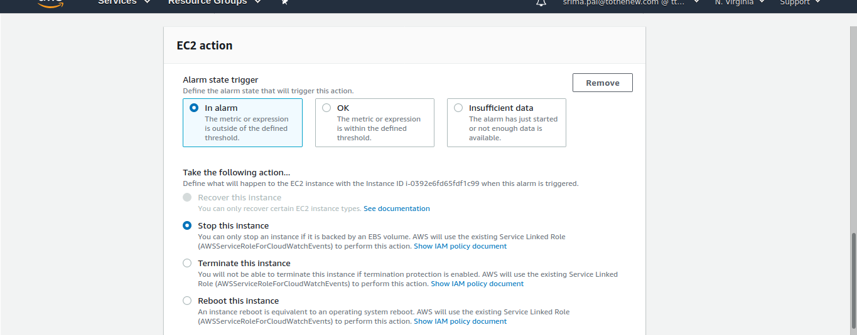

Give alarm name and description

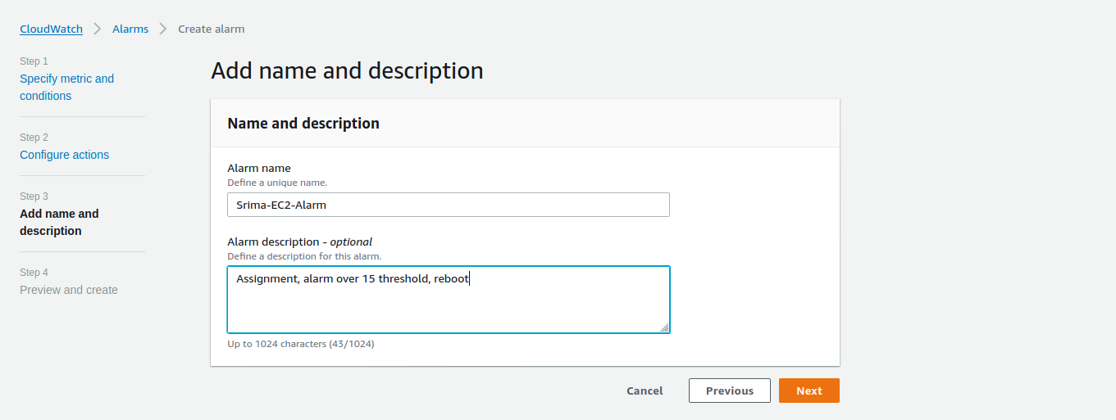

Alarm created

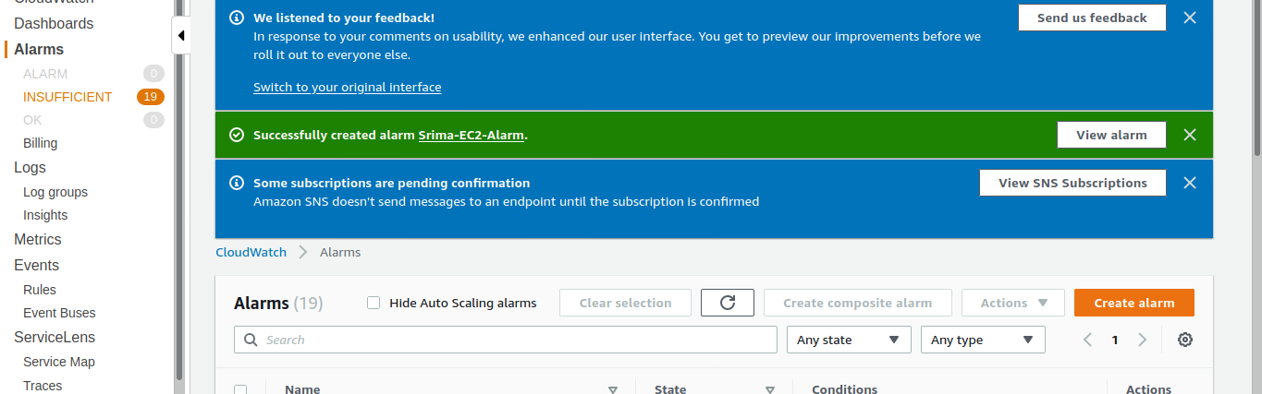

Confirm the email

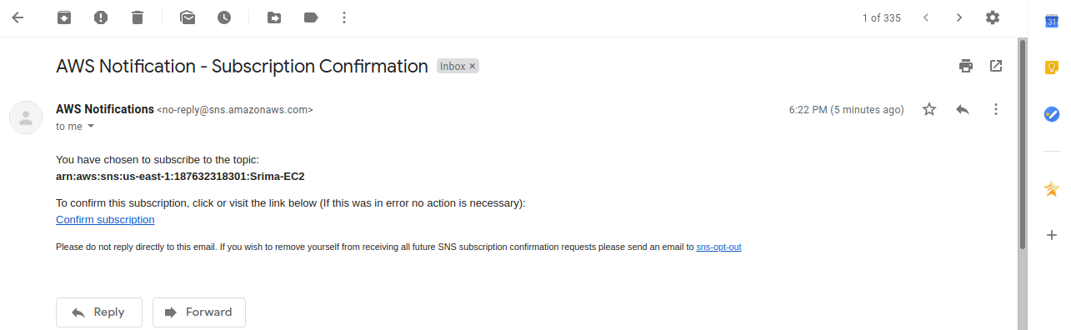

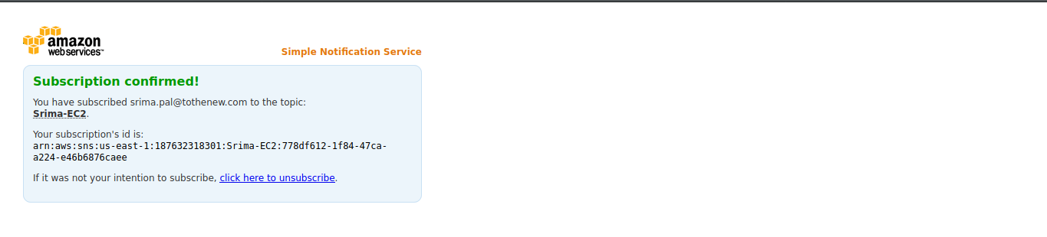

View status

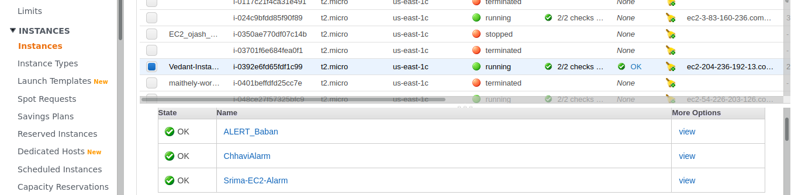

**2. Create a custom Memory metric in CloudWatch and set up alarm at 80 % which will autoscale the instance in the autoscaling group.**

Create a policy for cloudwatch ,with put metric data , giving permission to ec2 to put metric data in cloudwatch

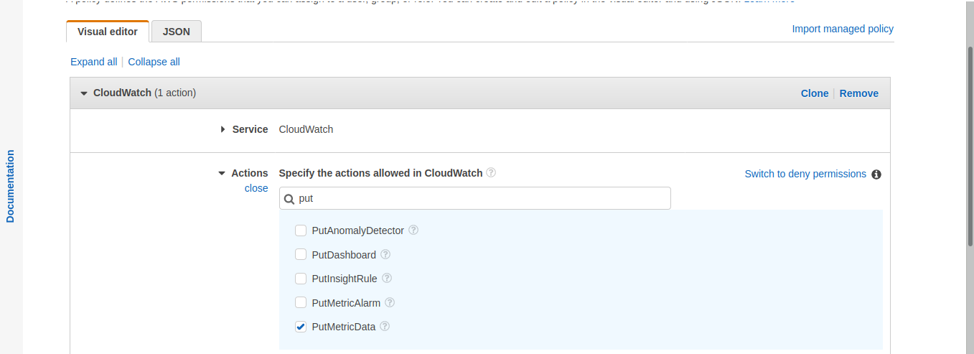

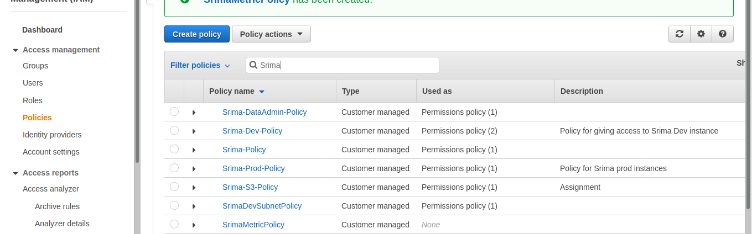

Attach this to the role, srima metric policy and cloudwatch agent admin policy

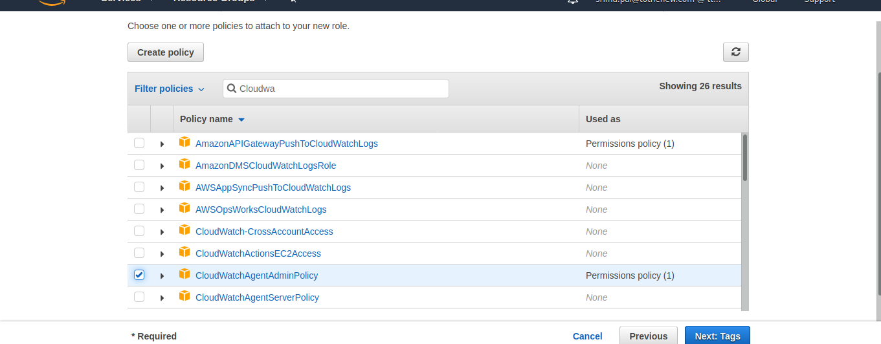

Create role

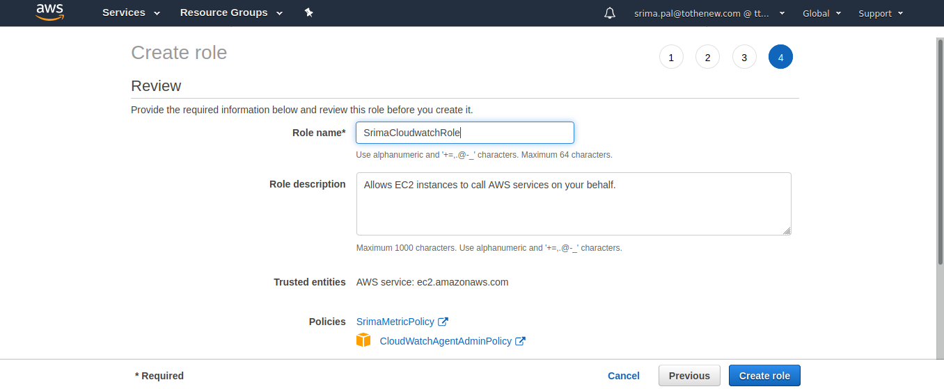

Attach IAM Role

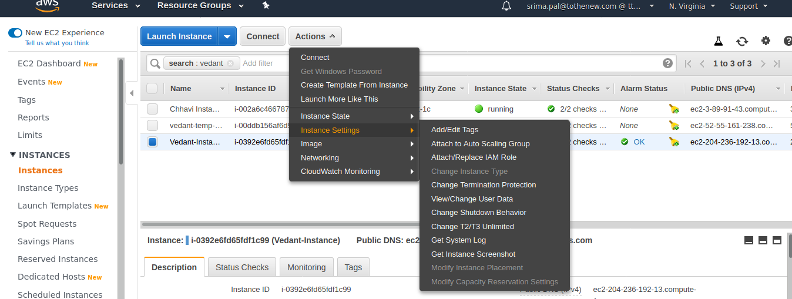

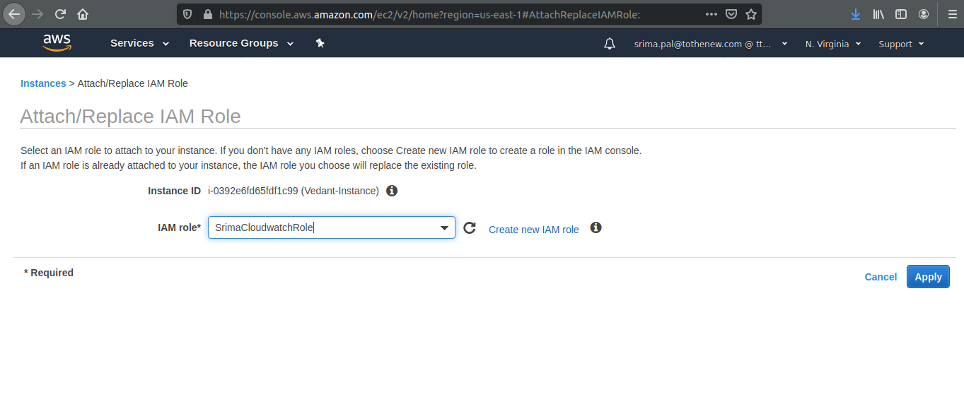

Create a script inside the instance

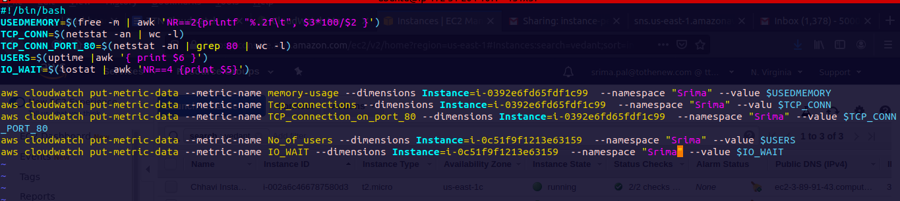

Give permissions (execute script)



Run the script to push the information of ec2 to cloudwatch



Metric Created

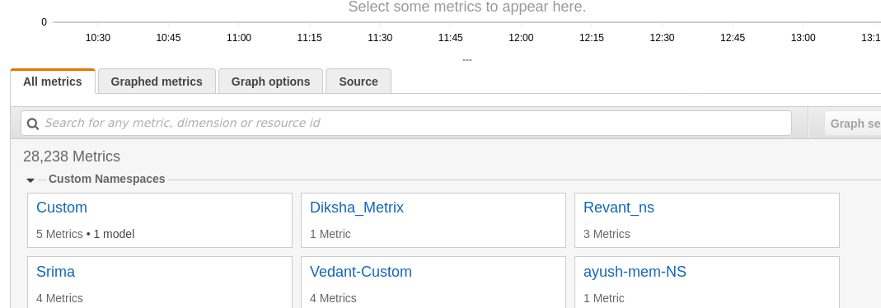

Set billing alarm, for memory usage metric

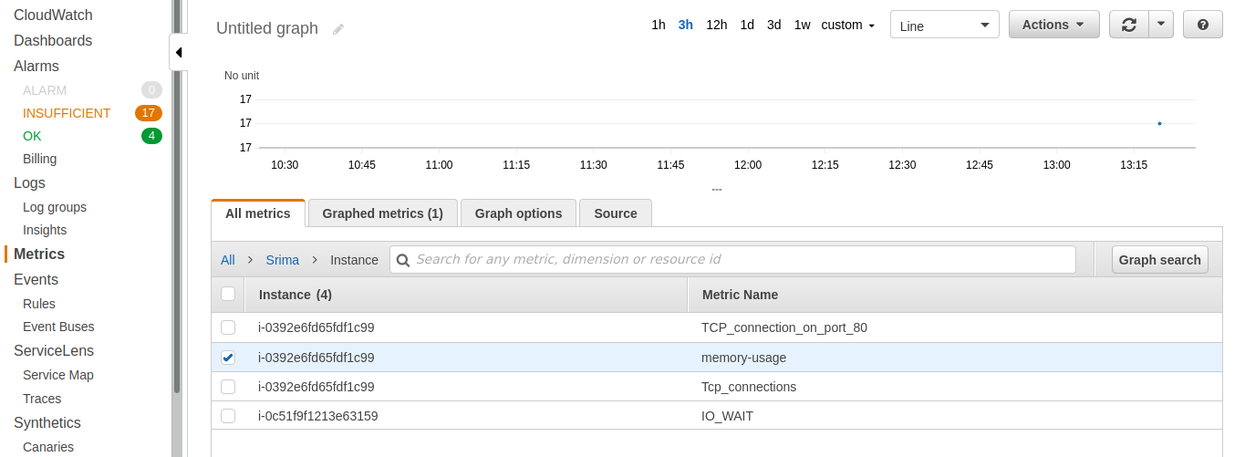

Go to alarm, and create alarm for the created metric

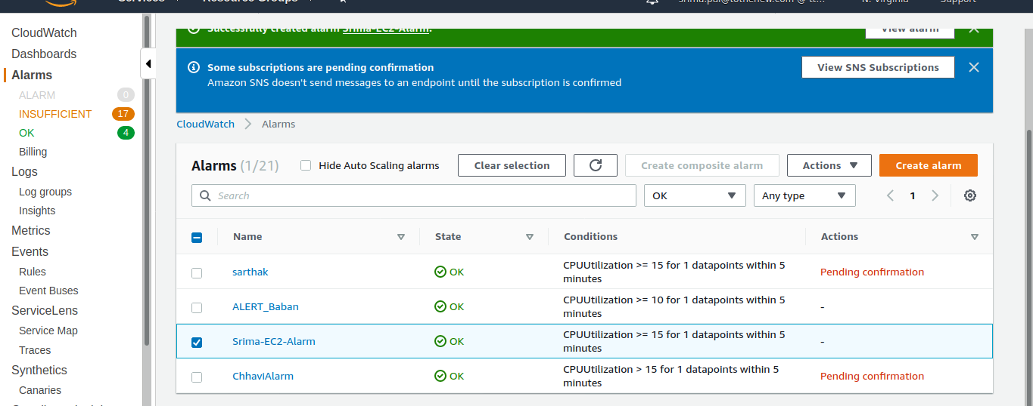

Select the metric

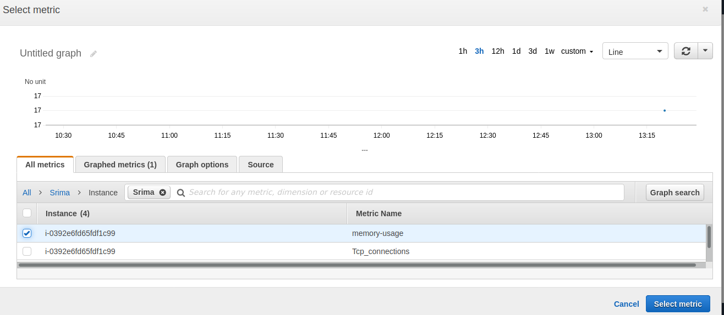

Created alarm

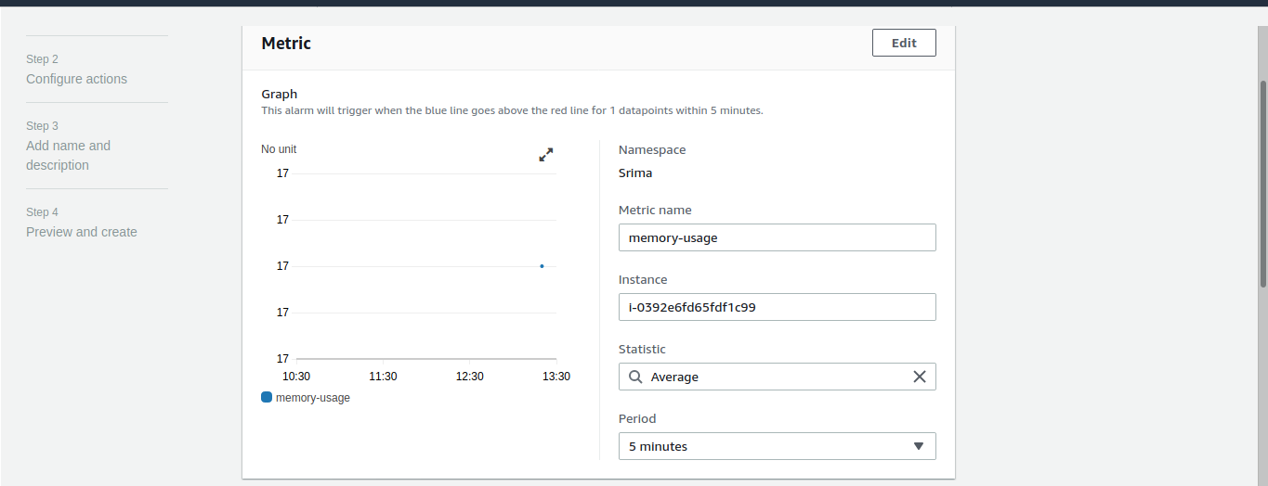

Give 80% threshold

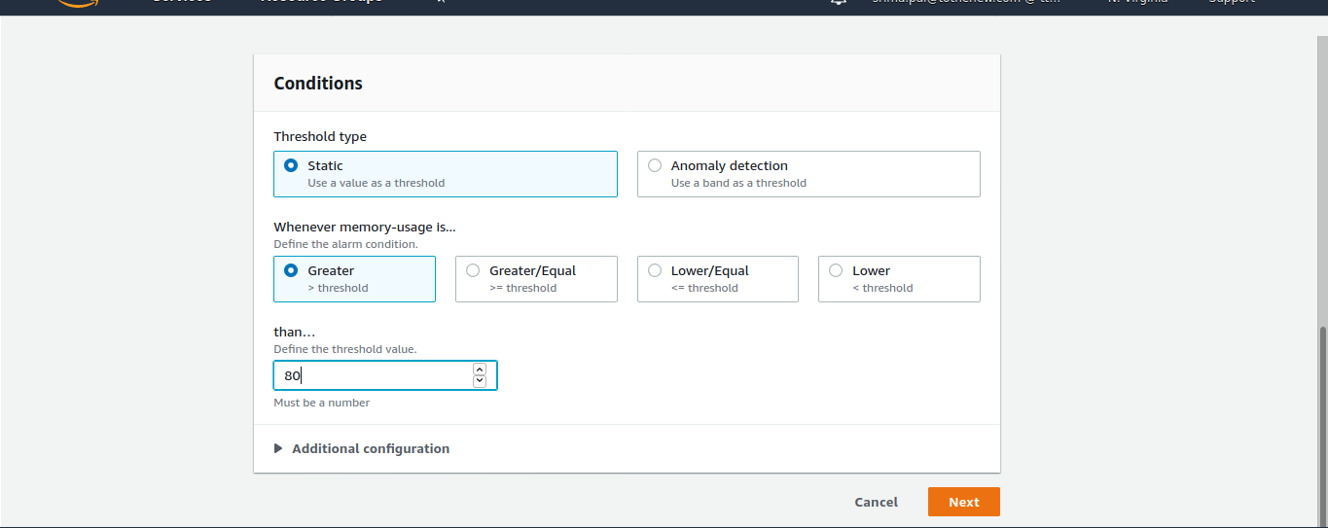

Create AMI , create ASG and set alarm in scaling policy

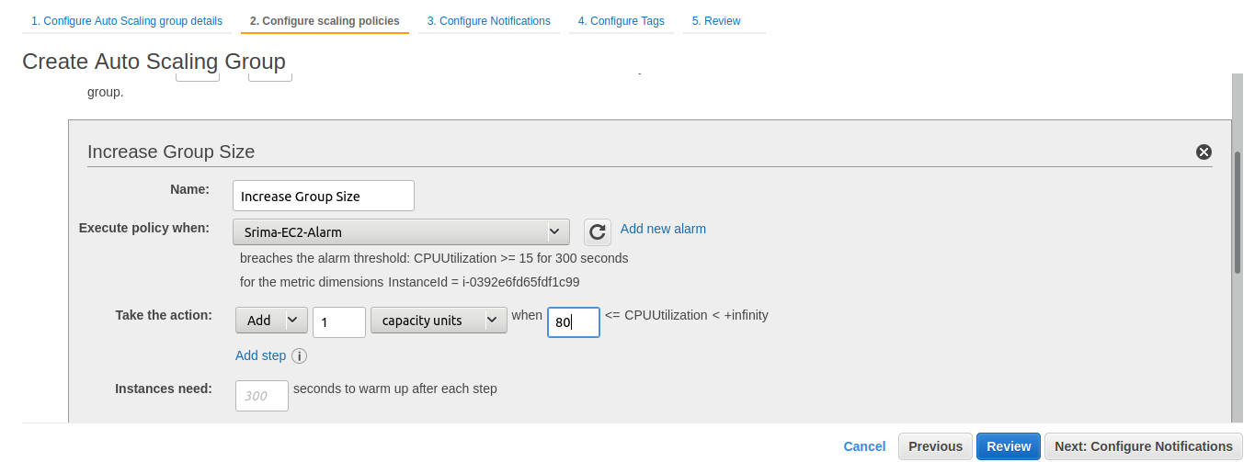

Add an autoscaling alarm, select autoscaling group

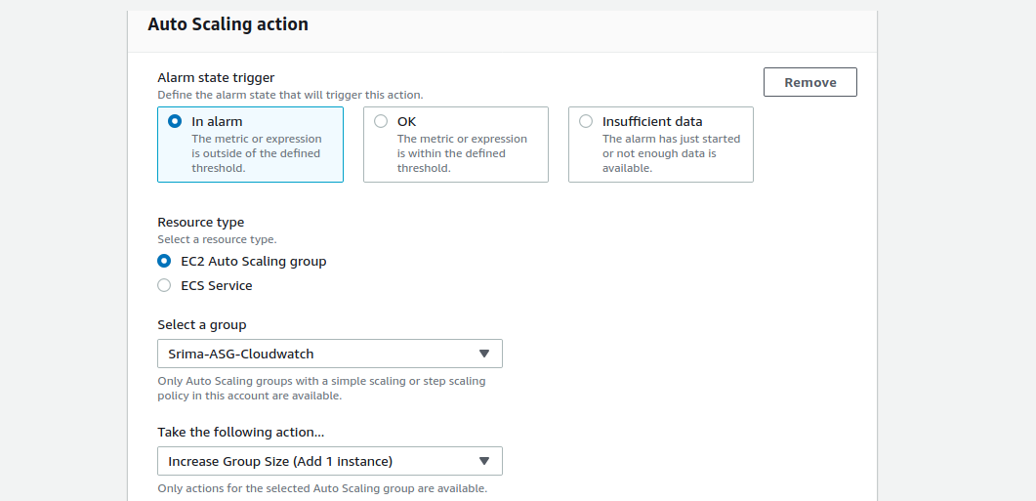

Select the SNS topic created

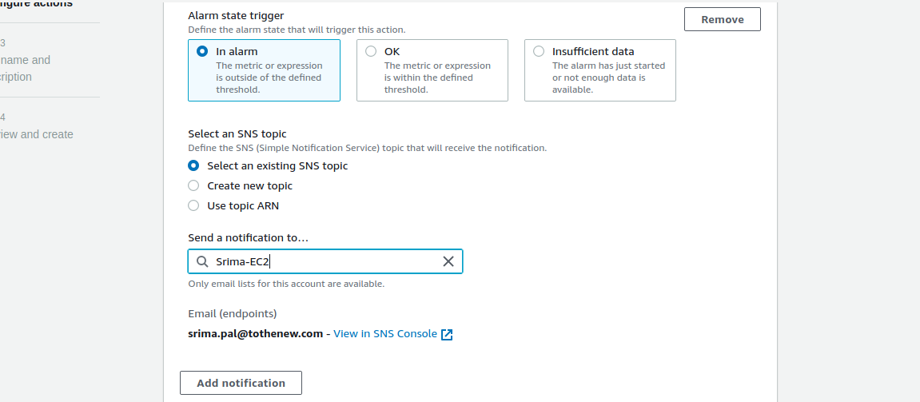

Give name

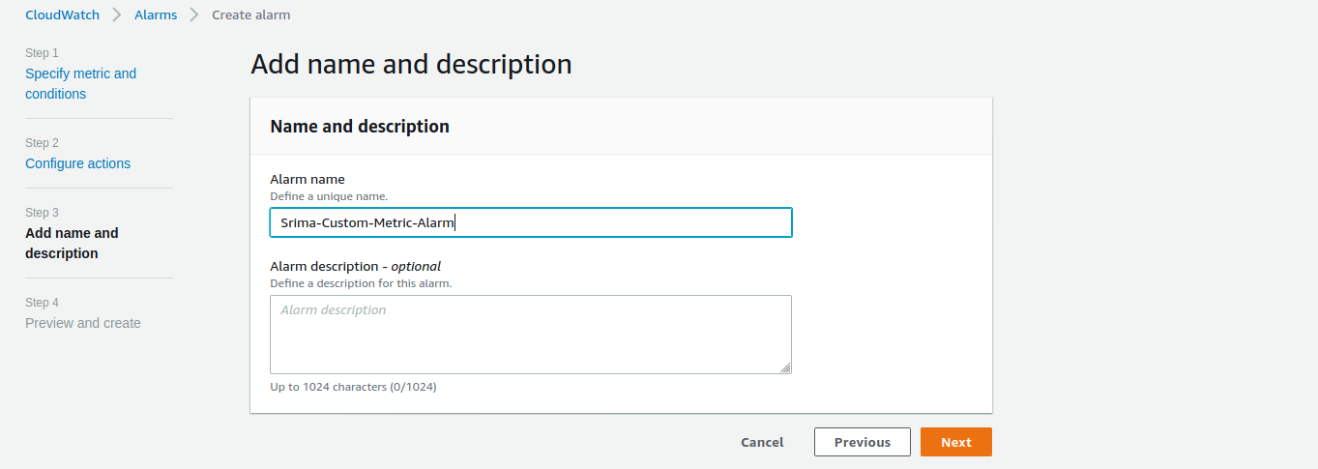

**3. Create SNS topic, subscribe to a topic, publish message, unsubscribe the message and delete the topic.**

Create a topic

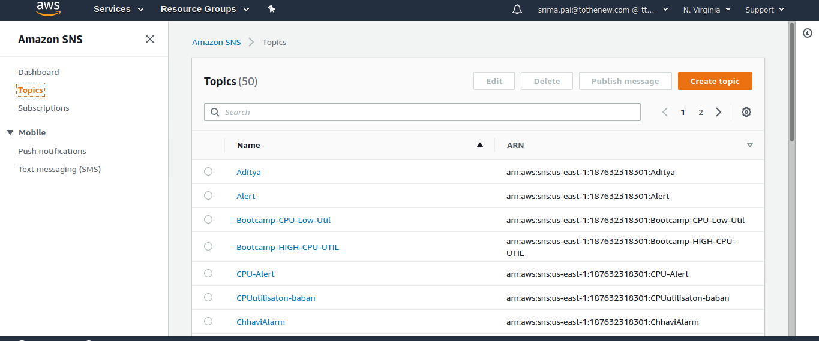

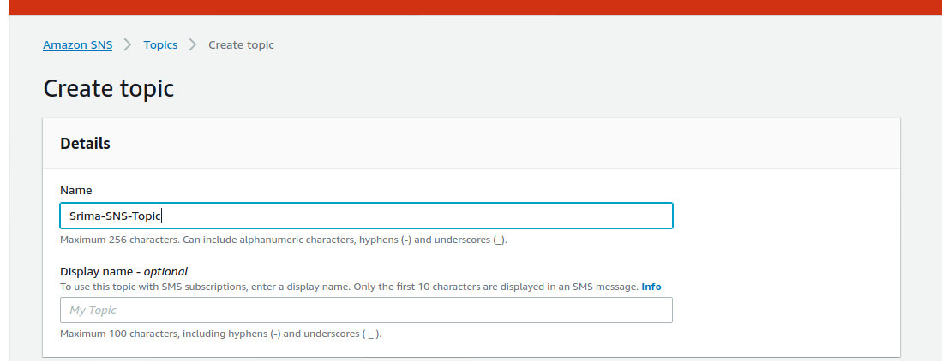

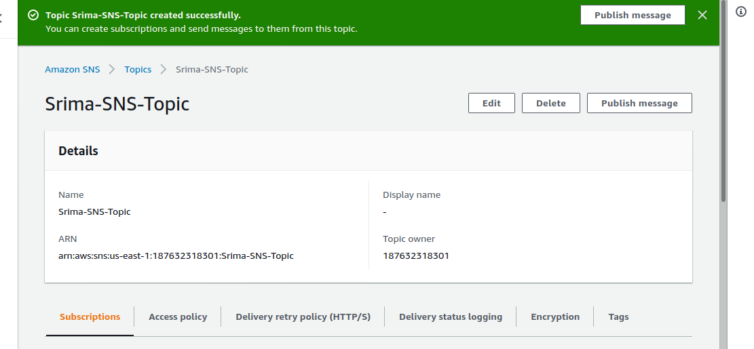

Create Subscription

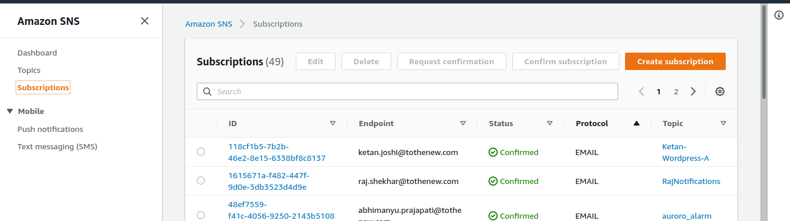

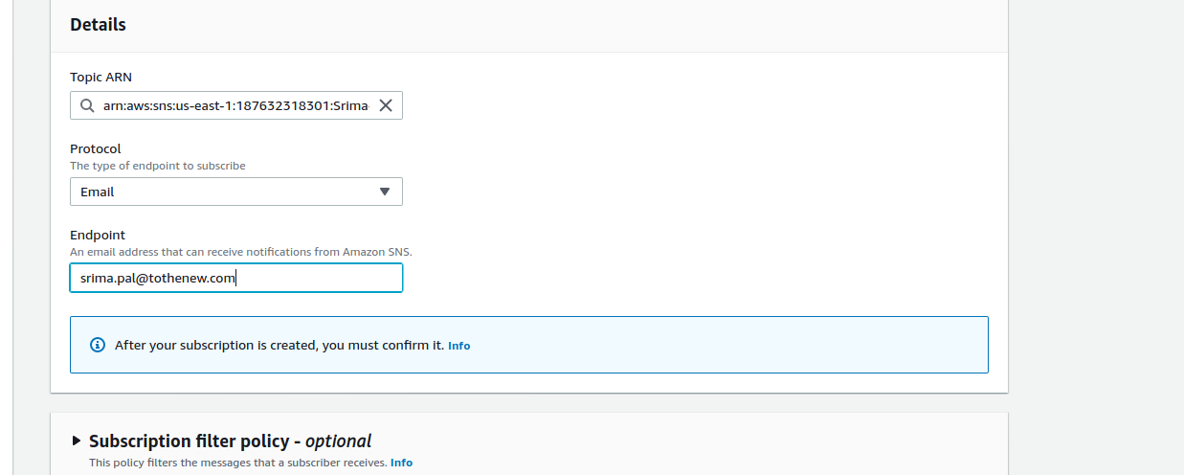

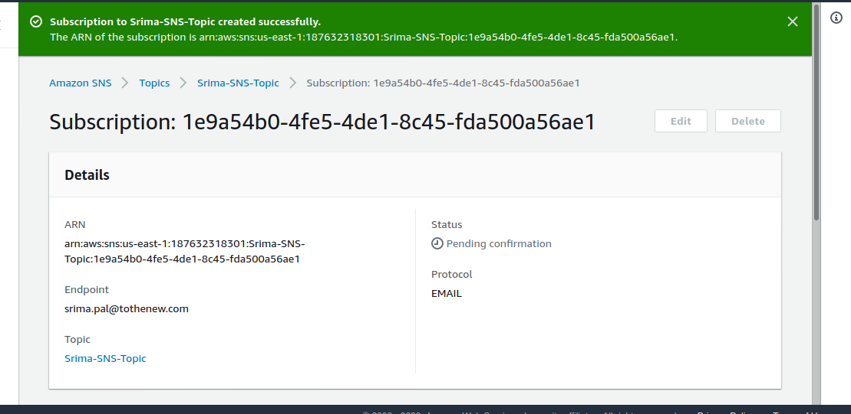

Subscriber needs to confirm the subscription

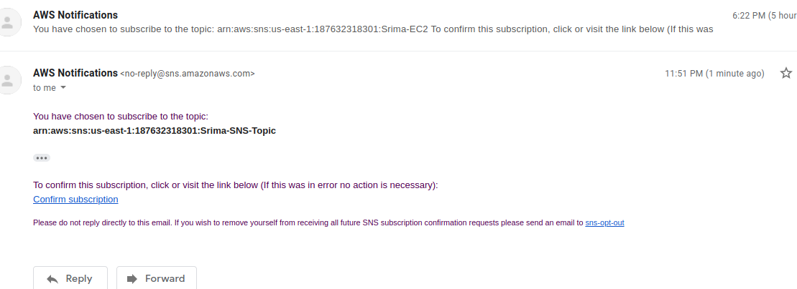

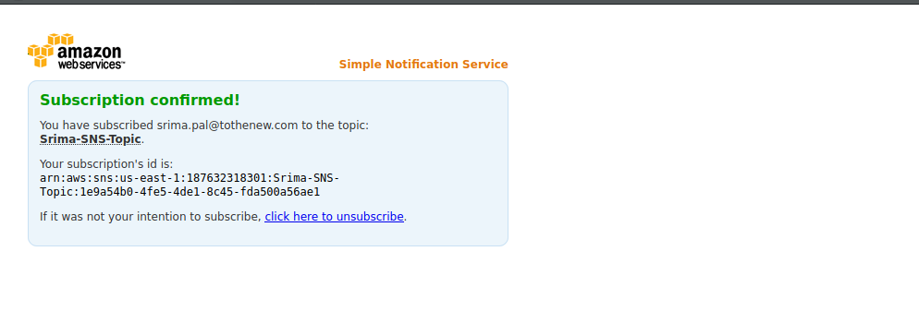

Select a topic and publish message

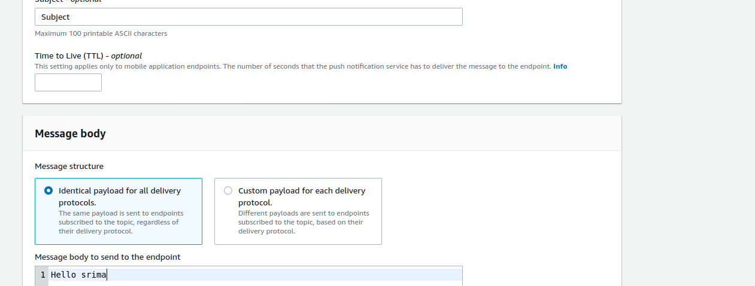

Email received

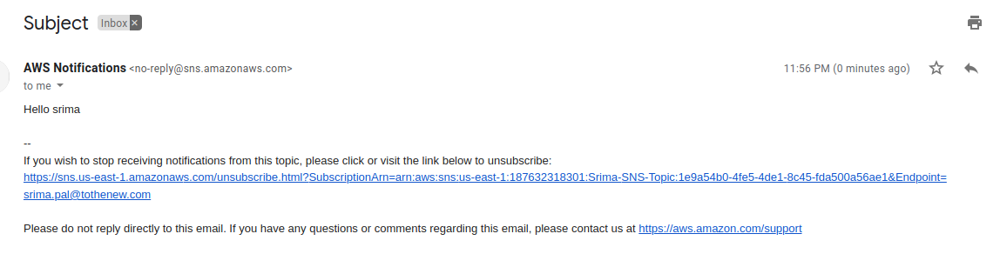

Unsubscribe to the topic

Click on the unsubscription link

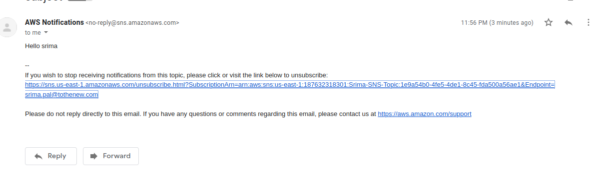

Unsubscribed

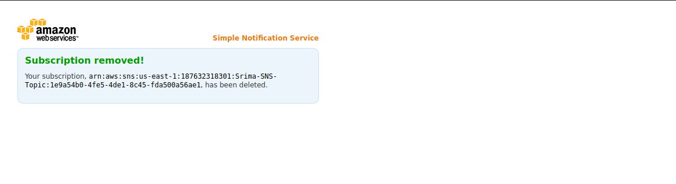

**4. Send a sample mail using SES (No access)**

